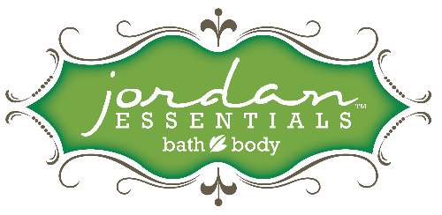
FACEBOOK LIVE PARTIES
Facebook Live parties can be a great platform for sharing your products more so than a Facebook post only show. JE products are represented much better when demonstrated in front of people.
The goal of any party is to bring benefits and share a story that compels the guests to engage, participate, learn, and then purchase from you.
Please watch the live training for Facebook Live parties 5 jars to health video and the how to with Lindsay Thompkins with Step into Success. Both are found in the JE Consultant Facebook Community.
3 reference documents:
- How to set up VIP Facebook Groups
- How to host coach Facebook Live parties
- Three bundle collections for Essential Health
Opening verbiage options:
You may think EO’s are hogwash like I did.
I did not even know where to start. You want to be healthier but the oils are intimidating.
I want to share for a few minutes some of the things I found. They really work!
You do have to be smart and safe for you and you’re family so we have to start with safety.

Here at Jordan Essentials we believe the skin is the best delivery system for oils and follow two basic rules.
#1 Never drink oils
There is no need! They go right into your blood stream leaving your delicate digestive system for food. They are very, very concentrated and could harm you.
#2 Put the oils into something before you put them on your skin! We call these carriers because they carry the oil to your skin.
Voila super simple 2 rules to successful oils

Ok here is what we found
Oils need to be 100% therapeutic grade and pesticide free. JE Check!
You only need a couple of oils at home to really get some great benefits.
Let me ask you a couple of questions:
- How many of you take a lot of ibuprofen, aspirin or other pain relievers?
- How many of you find you have trouble sleeping?
- How about stressed out during the day or wake at night with a brain full of stuff?
- Have a stuffy kid at home or family member you just hate to keep medicating?
- And finally just need some energy?
Which one sounds like you?
This is the point when your hostess would post a contest image found in you back office under Facebook party posts that you would have sent her before the party.

Your verbiage post
Which question can you answer “Yes, that is me!’
- I take a lot of pain relievers
- I have trouble sleeping
- I have a stressful day almost everyday
- I need more energy
- I have sick family members at home now and/or often
- ALL OF THE ABOVE!
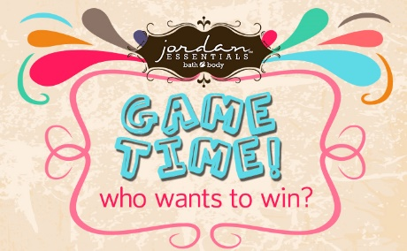
At the end of the show you can go back to this post and do a drawing for someone to win the jar they need most.
If there are 10 posts use random.org and it will pick a number 1-10. You go back and count down to that post and they win.
After you take orders then you can ship that jar with their order or just ship it or better yet wrap it up and deliver if they live close enough.

Party Script Cont.
Today I want to show you how to make 5 fun and fast sets you can keep at home to help support your health and alleviate symptoms
I have 5 mason jars. You can use any glass container or jar around the house. In the smaller bags of Dead Sea Salts you can mix them in our lined bags.

5 jars and supplies:
Use simple mason jars that are smaller than 2 cups. You can find these at big box stores, grocery and dollar stores. You want to keep it simple.
Your guests will begin to think of what they have at home they can use too.
We will show them the 5 jars and fill them and talk about the oils as you fill.
Have some cheat card with you. NO big deal. You will also need an Essentials Healthy living bundle.
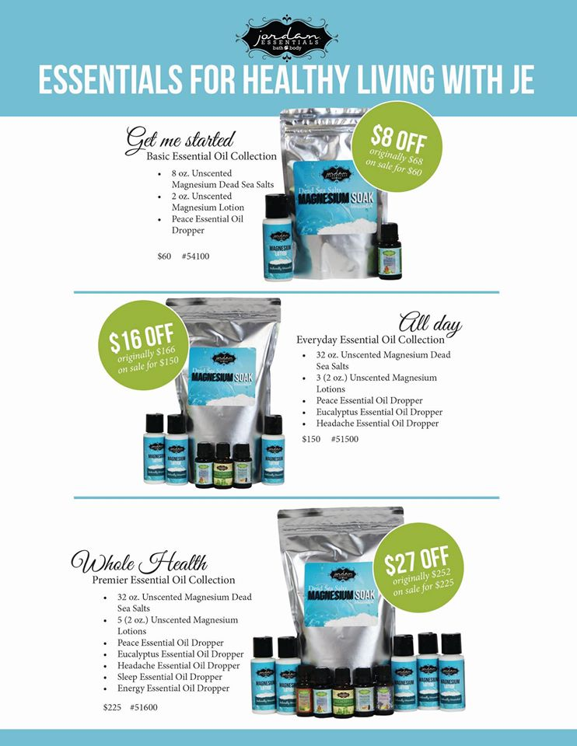
Talk about each oil as you blend. Then add how they can add to the 2 ounce Unscented Magnesium Lotion so after they soak they can finish with a lotion that enhances the experience.

Dead Sea Salts: I am going to use a lot of the text from the catalog.
Remember benefits sell! Tell what these oils will do for them. Add your own stories.
Party Script Cont.
People come from all over the world to soak in the Dead Sea for its proven therapeutic benefits. Aches, pains, many fibro customers, achy teens and athletes benefit from the rich salts and 21 minerals not found in any other body of water.
Our name comes from the Jordan River that flows into the Dead Sea!
We also power punch it with magnesium chloride. 55% of the population is magnesium deficient causing eye twitches, painful muscle cramps, nausea, anxiety and restless legs. Soaks and lotion will help benefit your goal of whole health.
Not a bath soaker? Get a dish tub from your dollar store and soak your feet. You will get some benefits from the large pores in your feet but not as much as a muscle soak.
Then you want to follow up with the essential oil of your choice in a Magnesium Lotion.
It layers the benefits and effects of your oils. Add oils to the 2 ounce Unscented Magnesium Lotion and it creates a little buddy.
As you talk about each item pick it up and show the camera.
Each oil bottle has over 100 drops of oil so you can see once you choose your collection you simply need to refill your salts and lotion.
Ok let’s get started.
I use about a cup of salt per jar. You need some room for shaking.
- Sleep
Lavender, Neroli, Orange, and Chamomile are blended together in a rich oil that helps you sleep.
They work on the sleep center of your brain much like a melatonin but no addiction or side effects.
You are filling the jar now and adding the drops from the bottle to the jar. You are going to demo this again and again. Do one jar you know you will use up in between parties and the rest you can add a little tape over the dropper or just tell them you would add and leave lid on. Waste not want not!
HOSTESS POST (have her post them as you talk about them or schedule this post ahead of time. Best if hostess is posting. You email her them ahead and she just copy and pastes them in there. She can add her own stories as well)
This little mom Jennifer says
Jeniefer O: Sleep spray!!! Feel much more rested even if I have only gotten a few hours!!
- Respiratory- Eucalyptus
Stuffed up can’t breathe make this little blend and then it is great to send with some chicken noodle soup to someone you love!
I would even have a can of organic healthy living chicken noodle soup to show how this would all come together.
It really opens air ways and helps you sleep.
HOST POST
Eucalyptus! helps fight a cold, allergies and sinuses to really open up those congested areas.. :)
- Energy
This blend is like a strong cup of coffee!
You know Peppermint is a pick me up and added to this blend with Lemon, Rosemary, and Eucalyptus it really puts a pep in your step.
Think of it as a morning bath, to help with circulation, energy, open air ways and refresh your spirit. It packs a kick so you only need a little. It is also a very good foot soak blend.
HOST POST
Shawna B In all honesty I have never been a believer in essentials oils until I tried the energy blend. My hormones have been so out of whack since pregnancy and having 2 different kinds of birth control in under 7 months, getting out of bed in the morning was such a chore but now I have all the energy to get up and get things done plus I have been working out. I have so much energy I'm working out and sticking with it. I've already lost 5 lbs and I wouldn't have done it without my energy essential oil!
- Peace- stress
This is our best seller. People just love it and so do I! It has an oil called Frankincense which is a precious oil is known to be uplifting.
Each oil was made by God with a purpose in mind. This is an uplifting oil and of course was a gift to the baby Jesus. That should calm your mind.
Here is what one person had to say about Peace…
HOST POST Vanessa M It's hard to pick just one. If I have to, I'll say Peace. I spray it on my pillowcases to help me wind down and sleep. During the day, I can smell the lava bead bracelet that I put a couple of drops on for those times that work frustrates me! And for those who have dogs that are scared of storms, put it on their collars to help calm them!
- Headache and pain soother
Headaches are caused by inflammation and tension that cause pain. So we call our headache a pain reliever because it really helps the nerve endings calm down and relieve tension in a muscle. This is quickly becoming our best oil we have and when paired with the Magnesium Lotion it is really powerful!
HOST POST
Lori H My favorite is the headache blend. I love how it smells & how it works for pain (especially when combined with magnesium lotion) & sleep!
Catherine J Headache is my favorite. I get both Allergy and Stress Headaches on a regular basis. I used to go through a bottle of Excedrin in 3 weeks. Since I started using Headache a bottle of pain reliever is now lasting about 3 months -- Such a difference.

Now you will go into talking about the bundles they can order.
I hope you are feeling more confident about Essential Oils and see how they can be practically applied to your life. Each of you picked a major concern in your life and I will be drawing here in just a minute.
We have 3 bundles to help keep you healthy and they save you money!
Pull each bundle together in front of the camera as you talk about it. Build to the biggest collection at the end.
Bundle #1 is our Basic. You get the best-selling Peace Oil, 8 ounce Dead Sea Salts and 1 small bottle of Magnesium Lotion.
This set is only $60! You save $8 when you buy this as one of my collections. You can make several jars, or for this one just add the oil to the bag since you have one oil. Excellent way to start your Essential Oil Journey or give as a gift.

Order now a bundle to make 5
Bundle #2 is our 3 pack Essential Everyday Health
Large Magnesium Dead Sea Salts, 3 oils: Peace, Eucalyptus and Headache Blend and 3 bottles of Magnesium Lotion for mixing.
This package is $150 and you save $14! We have great every day prices on all of our products as you can see and the bundles also save you money!
Bundle #3 is our 5 pack Whole Health.
Large Magnesium Dead Sea Salts, 5 oils: Peace, Eucalyptus, Headache Blend, Eucalyptus and Energy along with 5 bottles of Magnesium Lotion.
This collection is a great value when you think about how each bottle has at least 100 drops in it for 500 applications for you and your family! It is only $225 and you save $27 and is by far the best way to go.
Message me which bundle you want and I will set times to contact and collect your payment and order.
You can also look at our entire made in the USA nontoxic skin care line by clicking on the link below to our catalog.
We want to thank __________________ (your hostess) and to be sure she gets credit for her party please message me all of your orders and I am happy to give you excellent customer service.
Ok are we ready to see who won one of my cute shaker jars of Dead Sea Salts?!
Do the drawing now or have your hostess do that for you.
Announce who is the winner and thank everyone for coming.

