Essential Training Document
Jordan Essentials Customer Website Locator
Customers love shopping online. When customers shop with Jordan Essentials they have several choices to make their experience as easy as possible. You also want your customers to be able to shop with you, their Jordan Essentials Consultant, and guarantee you get credit for the order. Here are some how to about our system to help ensure a great experience for your customers and support you as a valued Jordie.
- The best way to ensure your customers shop with you is to use your web address. This is chosen by you at the time you joined Jordan Essentials. Myjestore.com/_________ . We encourage you to use your first and last name. People remember your name or have it on a piece of literature with them like a business card or catalog. Log into your back office and set up your own website and keep an active subscription for only $9.95 and your customers will always be able to find you.
- In the event a customer goes to jordanessentials.com they can shop and then will be prompted to choose a Consultant. (see image)
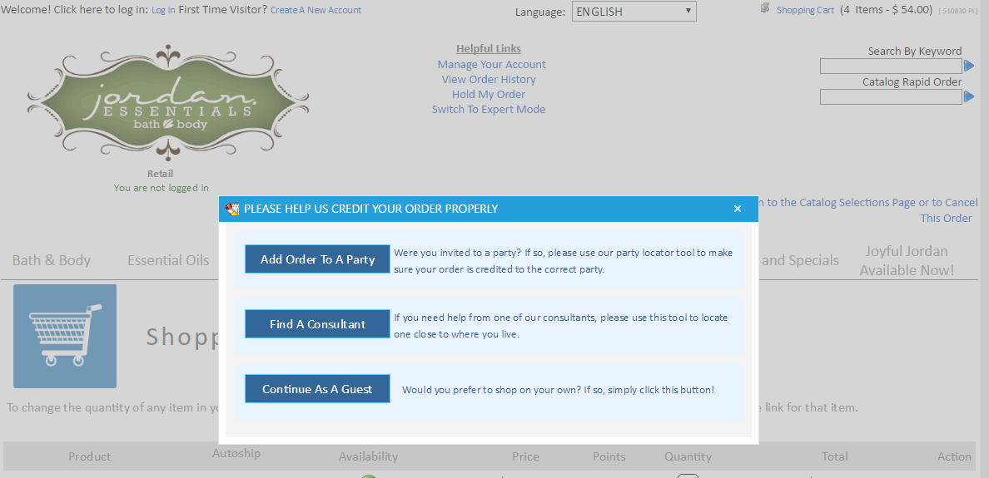
Add Order to Party: If they choose add their order to a party they will need to choose you as their Consultant and then all of your open parties will show up and they can choose the party they were invited to.
Find a Consultant: If they are just shopping with you they will choose find a Consultant and then they have 3 choices. (see image)
1. Shop as guest: Sometimes people just want to shop a website and give it a try. We assign those Customers to our Paid as Directors to care for and support after their purchase.

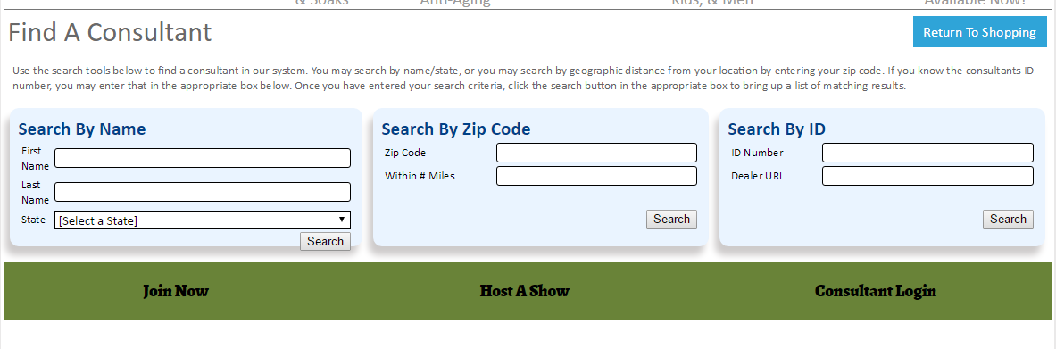
2. Search by name: This option has all of our Consultants who have a web subscription ($9.95) or are a new Consultant in your first three months. The assumption is your customer knows your name.
3. Search by zip code: This option is designed to help someone find a Consultant who may not have one. This zip code locator is set to refer and list only our Star 3 career title Consultants who have had $200 in the prior month and an active web subscription. Because we do not have minimums at Jordan Essentials we do not list all consultants as many may be personal use and not interested in building their business or actually have no sales at all for over a year or two. This option is for someone who is looking for a Consultant who may not have one. Many times because we are still growing “Jordan Essentials” will be the default if there are no Jordies with the qualifications in 100 miles. We will then assign them to a qualified Director as a new customer.
Search by ID lists all Consultants that are active in Jordan Essentials.
Customers who register on the website and choose a Consultant are permanently attached to you as their Consultant and each time they shop you are pre assigned to their account.

Marketing tips:
- Always put your name and ID on all of your print materials and products.
- Be sure your customers know your name and how to order. Go over how to order at each show.
- Use waterproof sticker (Rotek is a good source for labels)
- Do follow up phone calls 2 days after a customer purchases to see if they received all of their products. 2 Weeks later call again as a courtesy call and be sure they are using and enjoying the products. 2 months later call for reorders of most of your Jordan Essentials Products.
- Make friends! When your Customers are your friends they will be loyal and want to buy from you exclusively.
- Finally be sure your web subscription is current and active.

