PRE-POST – 30 MINUTES BEFORE:
The party starts in about 30 minutes so grab a drink, get a pen and paper, and let’s get ready to party Facebook Style with Jordan Essentials!!!
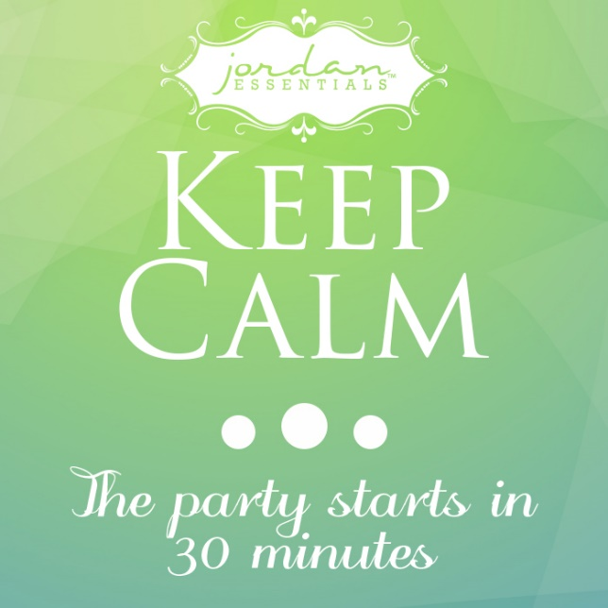

PRE-POST – 15 MINUTES BEFORE:
Only 15 minutes until party time! Who is excited??

PRE-POST – 5 MINUTES BEFORE:
Only 5 minutes until party time!! WOO HOO!!
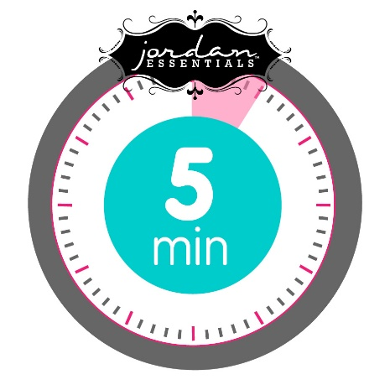

PRE-POST – 3 MINUTES BEFORE:

START PARTY:
POST #1:
We are so excited to welcome you to our Jordan Essentials Facebook Party! In the comfort of your home or anywhere; kick back, relax, and join us for games and shopping! We will answer any questions about skin care, essential oils, and our healthy natural mineral make up you might have.
1. Feel free to ask anything that comes up during the party. We will respond as quickly as we can.
2. Please refresh the event page every so often, so you can see the most recent posts and questions.
3. Sit back and have fun!
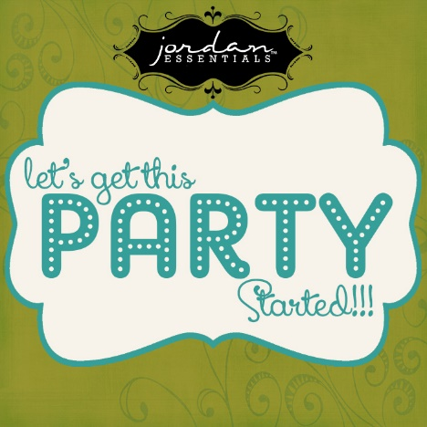
POST #2:
ROLL CALL & CONTEST #1!!
Let's see who is here! Post a comment below letting us know where you’re from - let’s see who “came” the farthest.
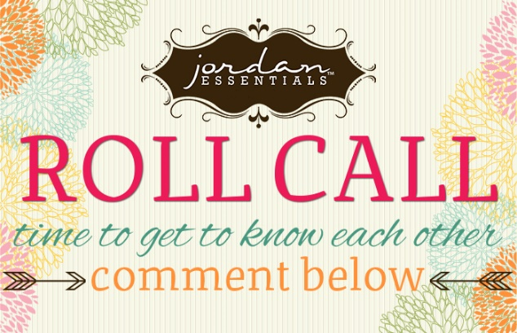
POST #3:
We are so glad you could join us tonight for a little ME time - Facebook style!!! Sit back and relax --- we are going to have a blast on here! This fast and fun Facebook party will feature information on products, parties, our consultant opportunity and prizes. I'd like to take a minute to introduce myself. My name is __________________ & tonight I’m going to be your party presenter!

POST #4:
This is Nancy Bogart -- Nancy is our CEO and Founder!
- Our company was founded in 2000 and is an American, woman-owned business. Nancy started Jordan Essentials 15 years ago= to help women keep their faith and family a priority.
- Our products are made in the USA
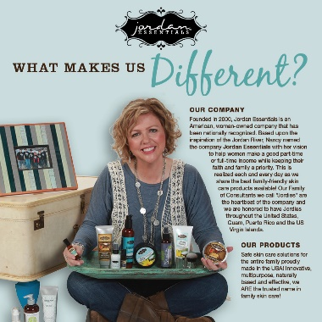

POST #5:
It's all about what we DON'T put in our products!
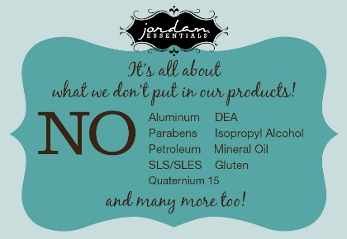

POST #6:
We offer Body Care that WORKS!
- Dead Sea Salt Collection - therapeutic mineral bath salts
- Shower Gel with aloe
- Salt Scrub - exfoliate & polish
- Hand & Body Lotion - with shea butter and sunflower oik
- Shea Butter - rich lotion helps eliminate dry skin
- Hydrating Body Spritzer - refreshes & hydrates skin
*Purchase products individually or in a set for best value.
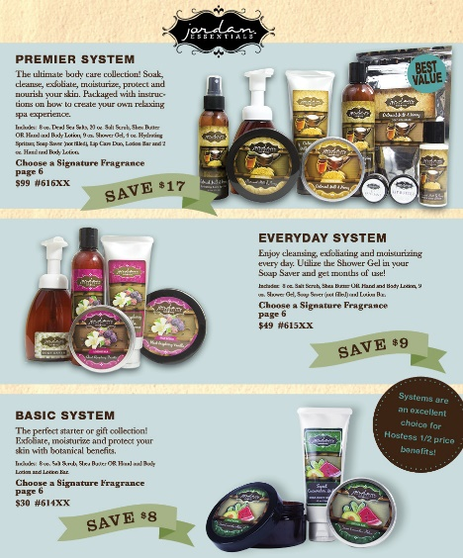
POST #7:
It all began with a LOTION BAR!
Nancy invented a solid bar of lotion with beeswax and natural oils that seals in moisture. The lotion bar comes in a decorative tin for easy storage and gifting.
Over 3 million lotion bars have been sold!
$9 each - your choice of 9 Signature Fragrances
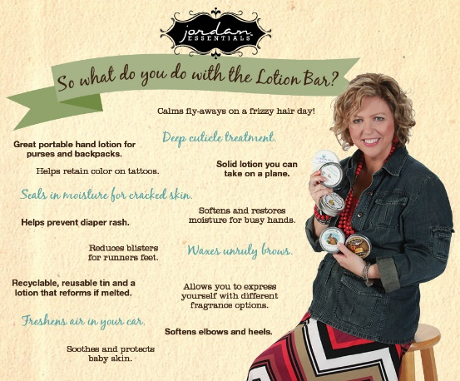

POST #8:
SKIN RELIEF:
A thick body lotion made with aloe, green tea, seaweed, chamomile, jojoba, shea butter and vitamin E. Great to help skin and reduce inflammation.
Helps soothe windburns, sunburns, scratches and skin irritations.
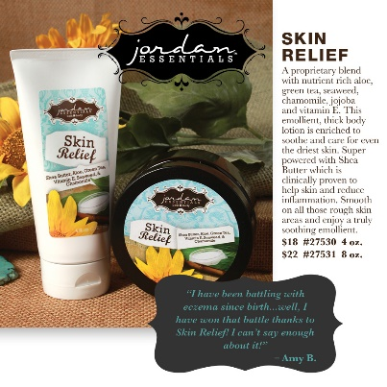
POST #9:
MAGNIFICENT MAGNESIUM:
55% of Americans are deficient in magnesium, according to the FDA which leads to eye twitching, leg & foot cramps, muscle pain, migraines and more.
Try Magnesium Lotion - organic ingredients like aloe, sunflower oil, jojoba oil and magnesium chloride. Available in Unscented or Peppermint Essential Oil in 2oz, 9oz or 17oz sizes.

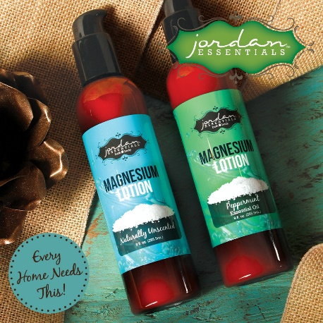

POST 10:
We have lots of amazing products that are effective and SAFE.
Two of my favorites are the Aluminum- Free Deodorant and the Alcohol-Free Hand Sanitizer!
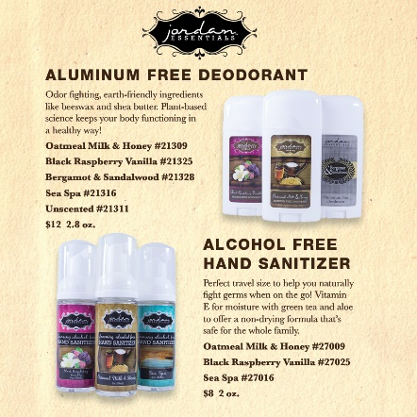

POST #11:
We even have products for MEN in our yummy Bergamot & Sandalwood scent.
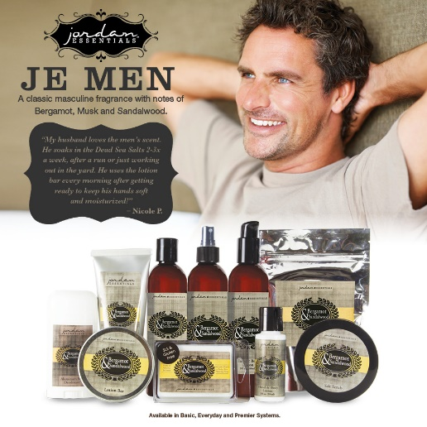
POST #12:
We offer an entire line of products for babies and another line of fun products for kids!
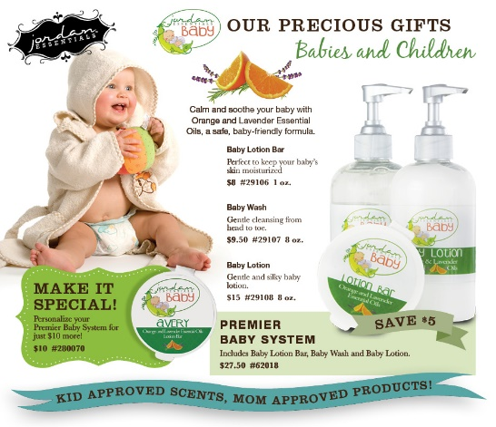
POST #13:
100% Pure Therapeutic Grade Essentials Oils:
Single note: Lemon, Tea Tree, Peppermint, Orange, Lavender, Eucalyptus
Blends: Sleep, Peace, Headache, Immune, Happiness, Slender, Energy
** Oils are sold individually in a dropper, roll on or spray. **
And there is a great deal -- this is our Basic Essential Oil Collection -- which saves you $18!
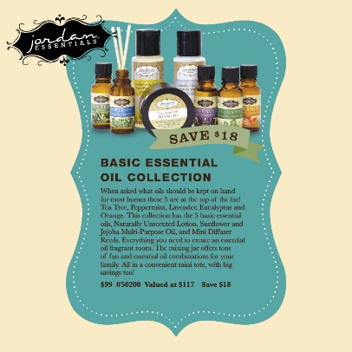
POST #14:
We offer a full Face Care line to cleanse, exfoliate, mask, tone and moisturize! We also offer treatments and anti-aging botanical products.
We have discounted full face care systems for all skin types - normal, dry, sensitive, oil and acne treatment. And the systems come with a special make up bag to hold them all!

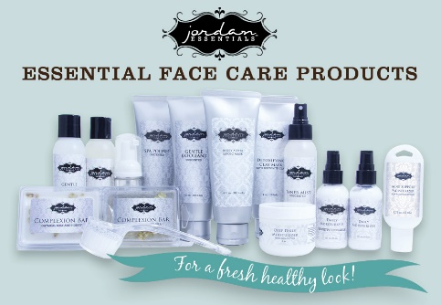

POST #15:
Mineral Makeup - a natural, flawless finish!
- Tinted moisturizer, mineral powder, concealer, mineral veil, lip butter lipstick, mineral eye shadow, and mineral blush!
Products sold individually or in sets at a special price!
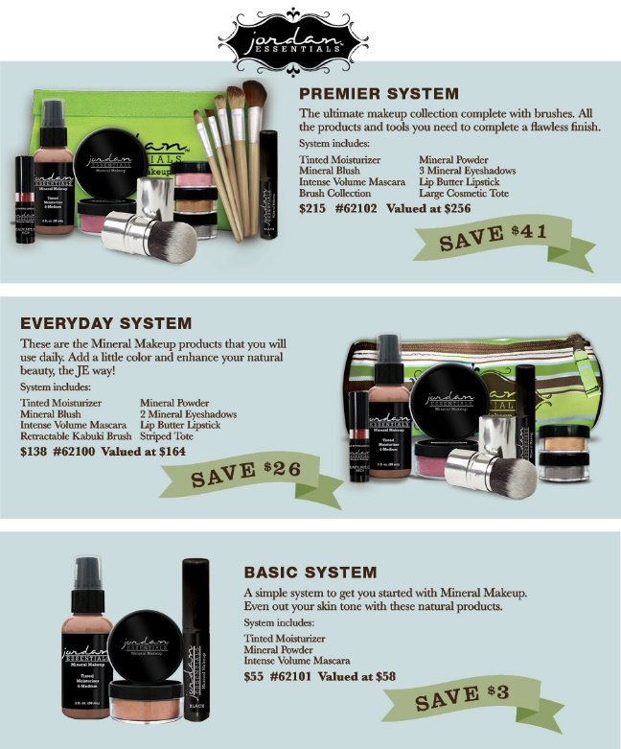

POST #16:
HOST A PARTY:
We can do them anywhere -- home, office or even online!
Earn FREE products & FREE Shipping!
Hosting a Jordan Essentials party is SO EASY & successful because women are looking for more natural products for themselves and their families!. Be the one who shares this incredible product line with them!
Contact the Consultant who invited you to book your Jordan Essentials party today!
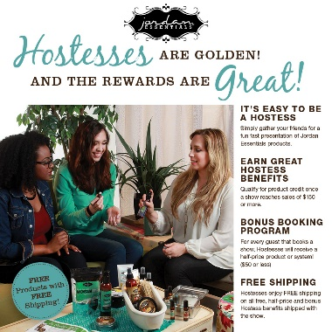
POST #17:
BECOME A JORDAN ESSENTIALS CONSULTANT:
We are looking for people just like you across the country to represent Jordan Essentials as Consultants and share our product with others. We offer 25% commission, product discounts, prizes and recognition, flexibility, free trips, advancement, fun, new friendships and more.
We can get you started right away and you can begin earning $$ as early as next week.

POST #18:
START JE TODAY FOR $99!!
You can start a Jordan Essentials business for just $99. Our business kit features over $330 in full size products plus all the sales materials you will need to get off to a successful start in the business. You can work this business online, part time or big time, the choice is yours!
We can get you started right away and you can begin earning $$ as early as next week.
Reach out to the Consultant who invited you here tonight for more information or visit www.jordanessentials.com .
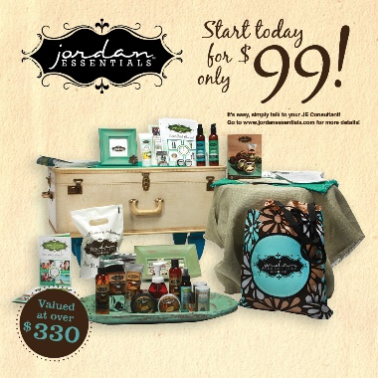

POST #19:
QUESTION & CONTEST TIME!!
Earn tickets for a chance to win _________________
We are going to take the next 5 minutes of our Facebook party to answer any product, party or business opportunity questions you have -- ask away!
Earn 1 ticket = For each product question you ask
Earn 2 tickets = For each "Host a Party" question you ask
Earn 3 tickets = For each "Become a JE Consultant" question you ask
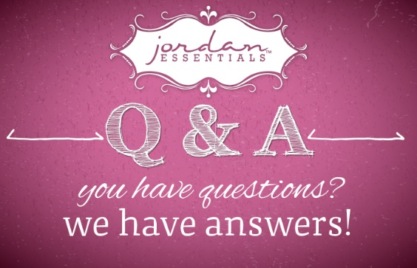
POST #20:
Click here to view the online catalog:
https://flipflashpages.uniflip.com/2/…/354072/pub/html5.html
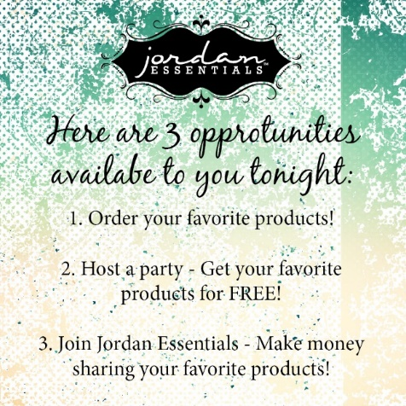

POST #21:
Thank you all for being here tonight for our Facebook Party and learning a little more about Jordan Essentials and what we have to offer you and your family! We will be available LIVE for a little while longer to answer any additional questions while we calculate our contest winner from tonight.
Please private message me to place your order, book a party or talk more about joining the business.

