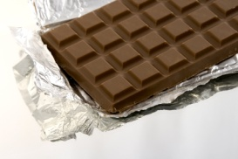
CHOCOLATE LOVERS’S PARTY!
State on the invite that this is a chocolate lover’s party! Everyone that brings a chocolate candy or treat to share will receive a free drawing ticket. (Have some treat bags available for everyone to take home a variety of candy for their candy dish!
Have everyone number their paper from 1-12 and answer the following questions and see who has the most correct. Have fun!! The Person with the most correct answers will receive a free drawing ticket.
- Super man’s favorite Candy: The Clark Bar
- The Happy Candy Bar: Snickers or Almond Joy
- The Planetary Candy Bar: Milky Way or Mars Bar
- The Candy that road through town naked on horseback: Godiva
- This candy bar that has an address: 5th Avenue
- It was ETs favorite candy: Reece’s Pieces
- It is the lover’s candy: Kisses or Hugs
- It is the alphabetical candy: M&Ms
- The candy made in Pennsylvania: Hershey’s
- The baseball candy bar: Mounds or Baby Ruth
- The bird candy: Dove
- The animal or pet candy: Kit Kat

